Explore Dubai

By

Pervesh

Level-6

Final Project

Table of Contents

Project Proposal 3

Goals and Objectives 3

Project Scope 3

Project Specifications 3

Target Audience 3

Project Deliverables 4

Resource Requirements 4

Project Tasks and Milestones 4

Project Assumptions 5

Project Report 5

Detail Design 6

Home Page 6

All Attraction Page 6

Support Page 7

All Attraction Admin View 7

All Support Admin View 8

My Details Register View 8

My Attraction Bookings User View 9

Attraction Booking Register View 9

Project Testing 10

User Manual 10

Summary 10

System Configuration 10

User Access Levels 10

# 

# Project Proposal

## Goals and Objectives

The main goal or aim of the project is to implement an online web application named “Explore Dubai”. The main purpose of the application is providing residents of dubai to expore and visit the attractions free of cost. In this application there are two types of users- admin and registered visitor. Admin has different functionalities as compare to registered visitor. Admin can add, edit, delete and check details of all attractions and maintain the Support section of web application.

## Project Scope

The scope of this project is to implement an app named “Explore Dubai” with the help of which user can find all attraction details as well as control their bookings. The duration of the project is 20 working days which is equals to 4 weeks.

## Project Specifications

* Admin login/logout
* Add, edit, delete and check details of Attraction by admin.
* Admin can delete, edit and check Support details.
* Admin can view personal details of user as well as Attraction booking details.
* Admin can register new admins.
* Registered Visitor can login/logout.
* New Visitor can register.
* Registered Visitor can control their Vaccine Booking process.

## Target Audience

The target audience for this project is the people who are permanent residents of UAE Dubai want their Attraction booking process at ease. The age can go from 18 plus to 90 plus.

## Project Deliverables

The deliverables of the project are:

|  |  |
| --- | --- |
| **Deliverable** | **Description** |
| Final Report | This will be the final report of the project. |
| Coding | The executable code of the project will go under this. |
| Documentation | This portrays the documentation of the project. |
| Testing | All the test details will be covered in this part. |

## Resource Requirements

* Windows Operating System.
* Microsoft word for documentation.
* Asp.net MVC Framework
* 64-bit Processor and 4 GB or more RAM
* Identity framework- ASP

## Project Tasks and Milestones

|  |  |  |  |  |
| --- | --- | --- | --- | --- |
| **Tasks** | **Week-1** | **Week-2** | **Week-3** | **Week-4** |
| Brainstorming and analysis |  |  |  |  |
| Planning and initial meeting Project Proposal document. |  |  |  |  |
| Database Design and UI Design |  |  |  |  |
| Identity framework implementation |  |  |  |  |
| Coding for admin and reporter |  |  |  |  |
| Testing |  |  |  |  |
| Final Documentation and closing |  |  |  |  |

## Project Assumptions

Following are the assumption made while implementing the project:

* One admin and registered visitor will be registered by default.
* Application will be free and open source.

# Project Report

#### Functional and Non-Functional

|  |  |
| --- | --- |
| Users | Functional |
| Admin | * Login/logout * Register new admins * Admin can add, edit, delete, check details for Attractions. * Admin can edit, delete and check details for Support. * Admin can view personal details of user as well as Attraction booking details. |
| Customer | * Can view details of Attraction and Support related to Attraction Booking * Can control their process of Attraction booking * New customers can register for free. * Login using valid credentials |
|  | Non- Functional |
|  | * High speed * Fast Loading time * High performance and security * All browsers compatibility. |

## Detail Design

### Home Page

The main landing page of the application. On navigation bar options are- Home, All Attractions, Attraction Booking, Support, Register, Login.

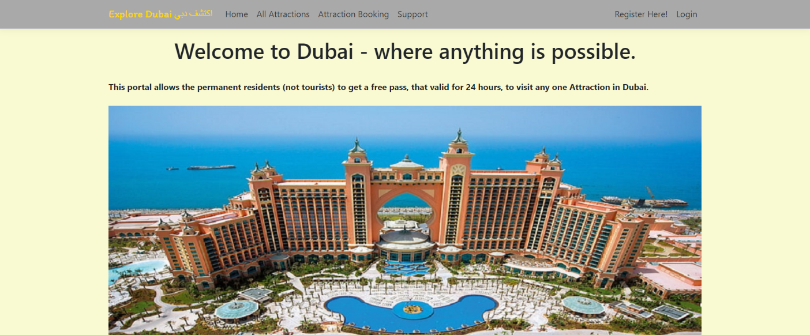

### All Attraction Page

With the help of this page, new visitor can view attraction details

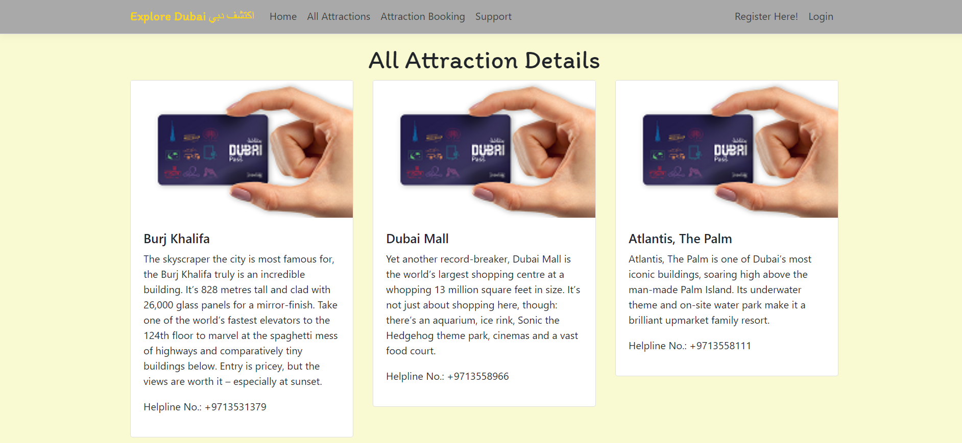

### Support Page

With the help of this page, visitor can view Support related Explore Dubai.

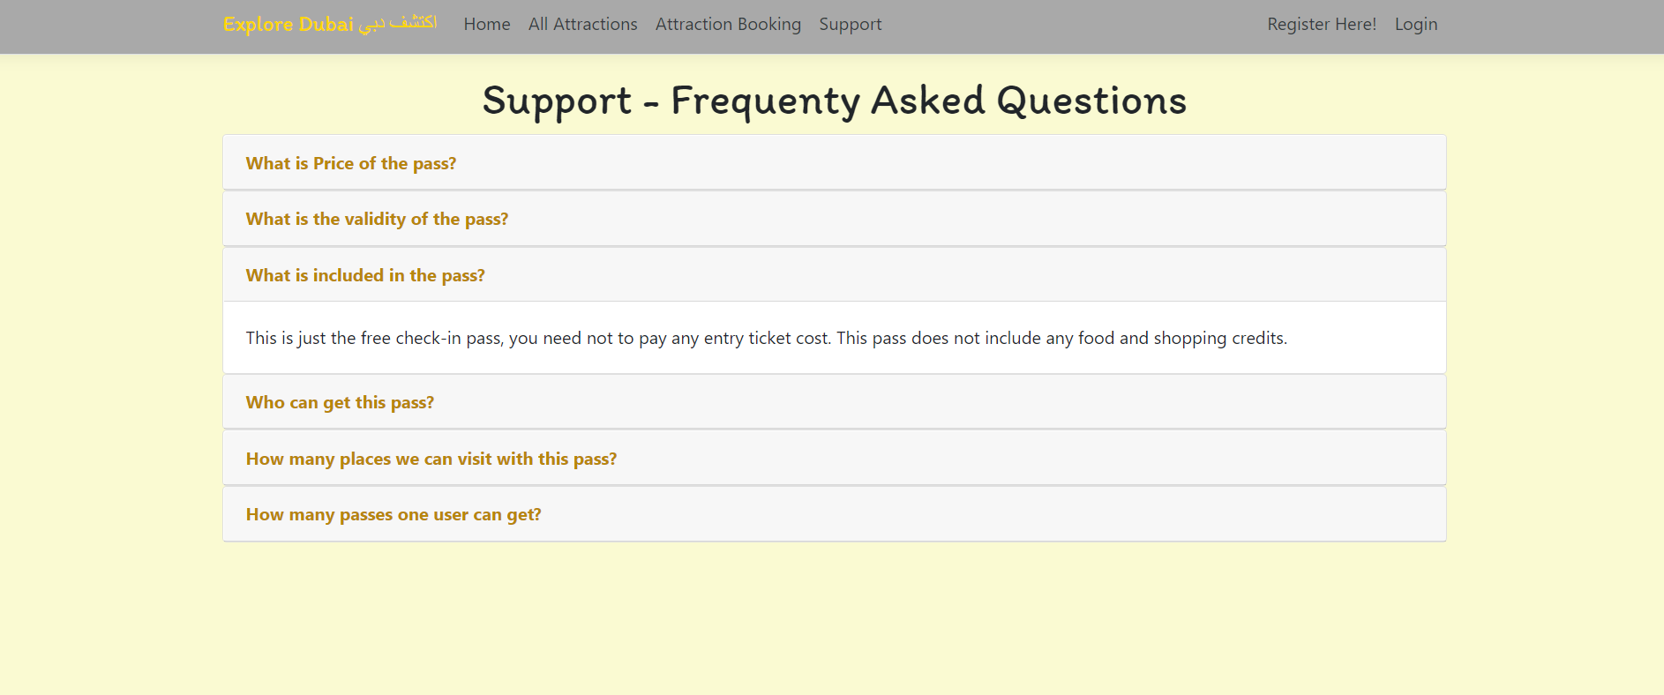

### All Attractions Admin View

This page highlights all the Attraction in Dubai available on the application. Admin can delete and check details of the existing ones.

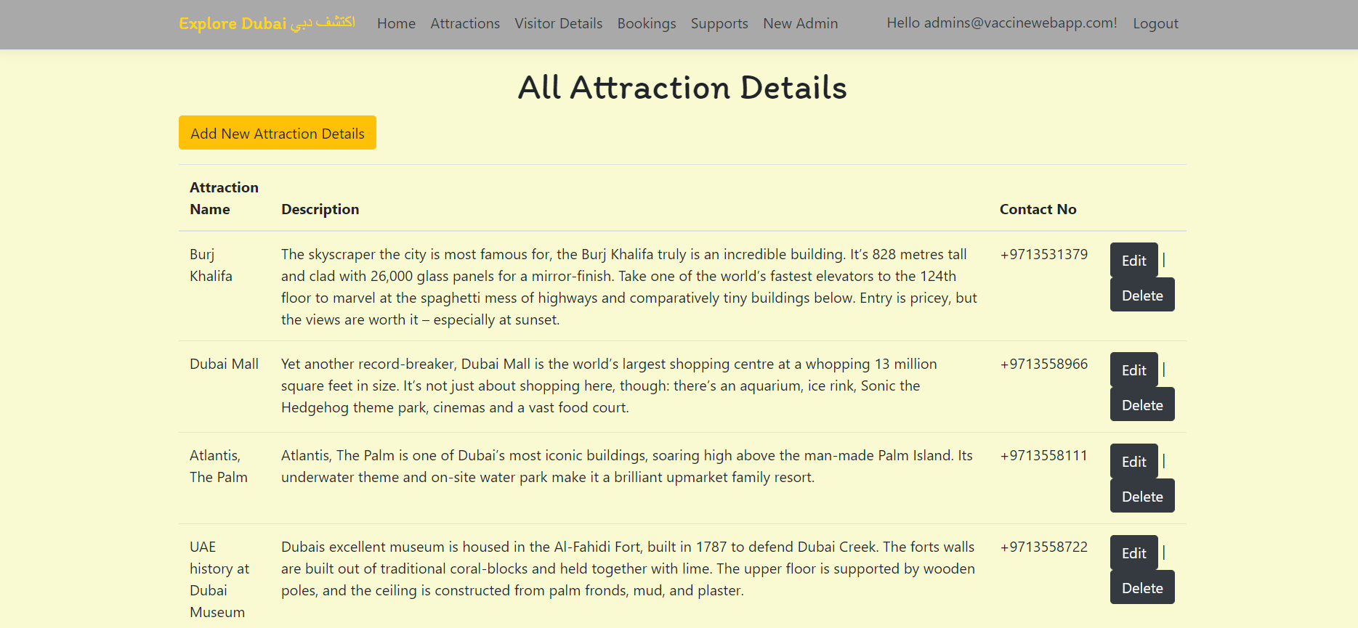

### 

### All Support Admin View

With the help of this page admin can manage the Support details by editing, deleting and checking their details.

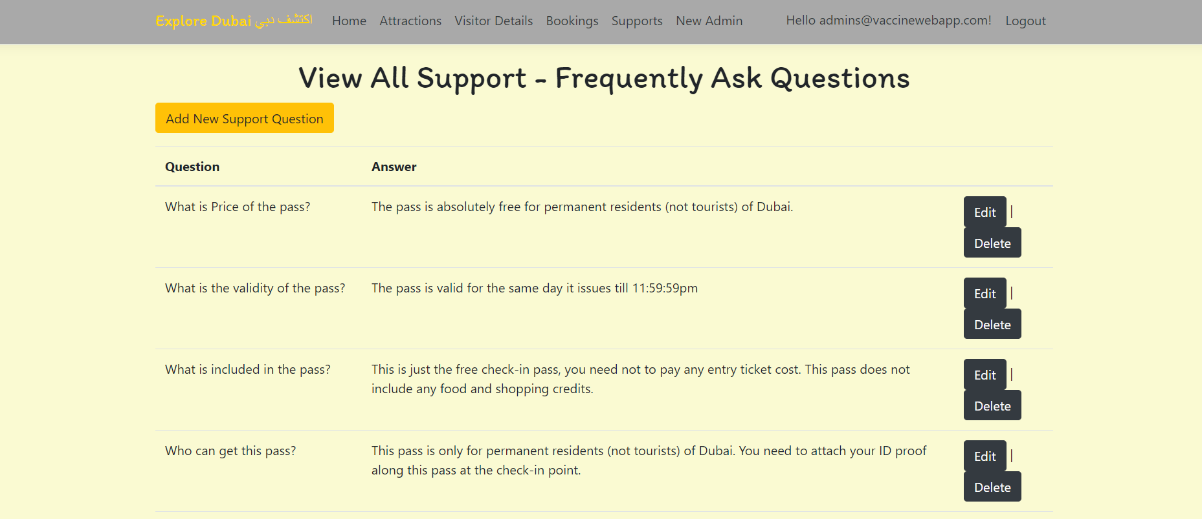

### My Personal Details User View

With the help of this page Register can view his/her personal details.

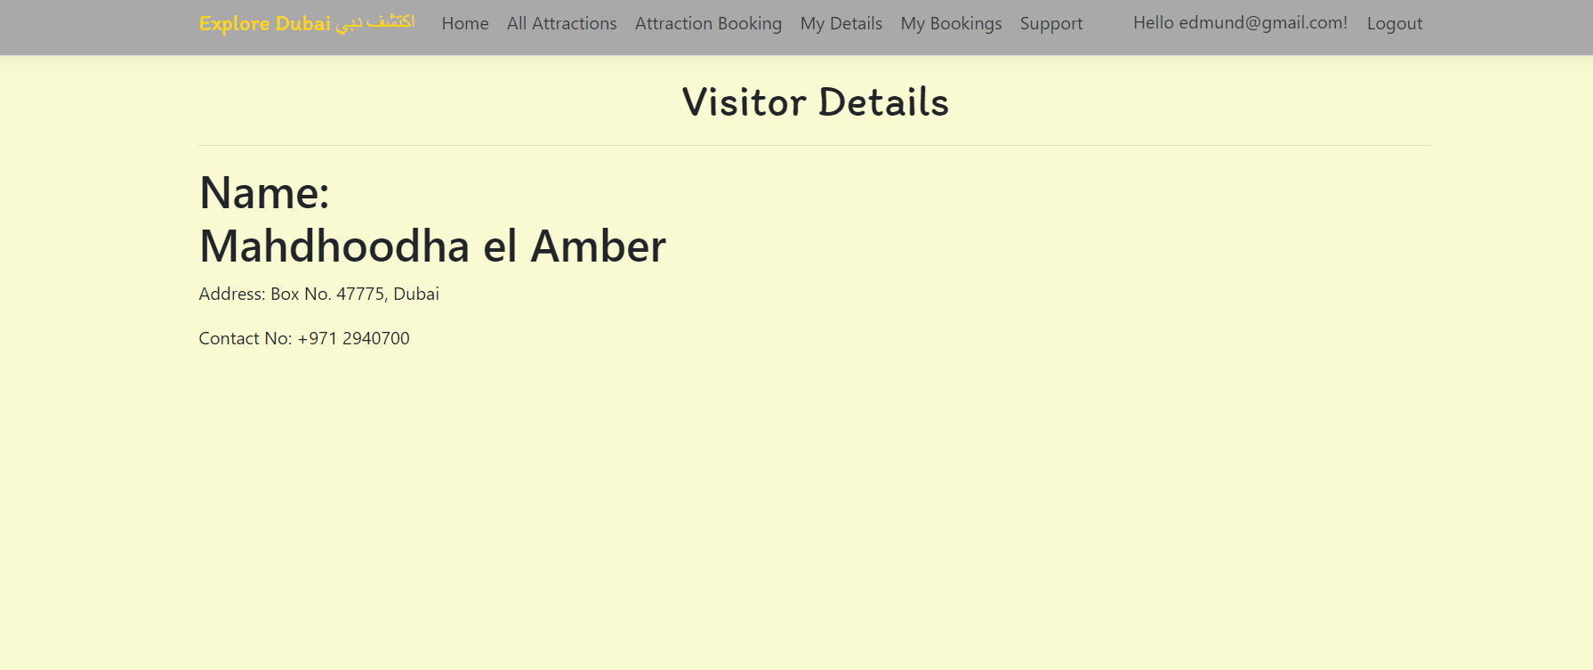

### 

### My Attraction Booking User View

With the help of this page register can check the details of the Attraction Booking and link to cancel booking.

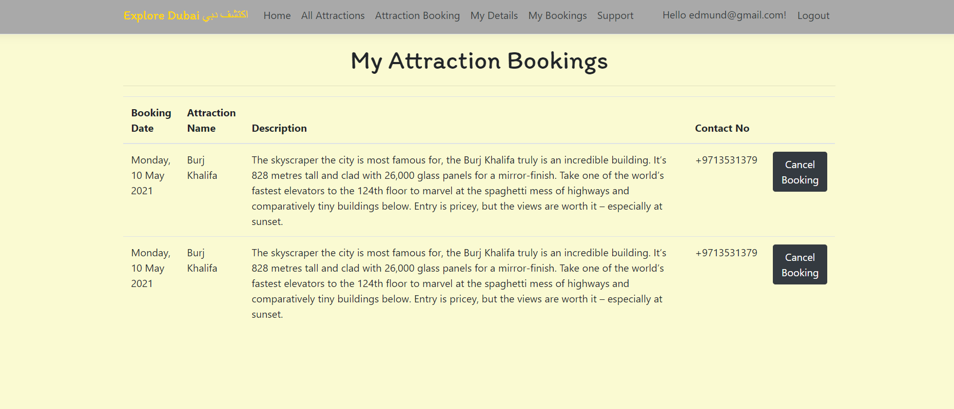

### Attraction Booking User View

This page shows the Attraction Booking Form for User User

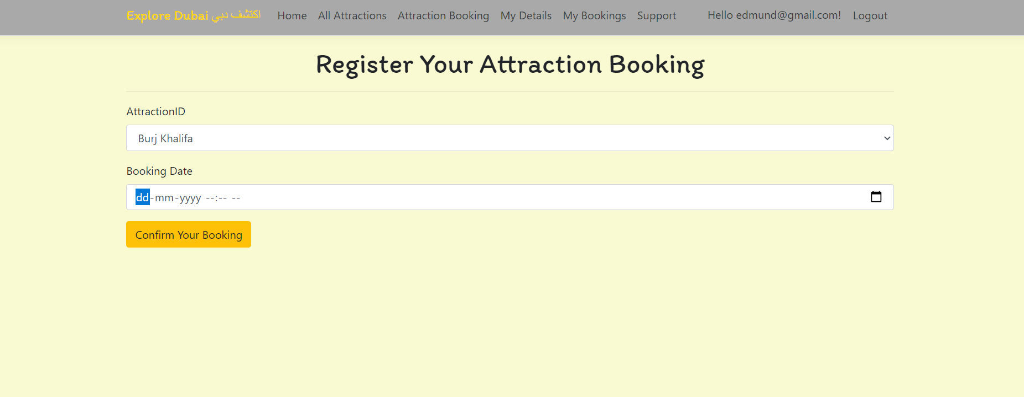

## 

## Project Testing

The testing file for usability testing is attached as [usability test.xlsx](usability%20test.xlsx)

# User Manual

The main purpose of the application is providing residents of Dubai to expore and visit the attractions free of cost. In this application there are two types of users- admin and registered user or visitor. Admin has different functionalities as compare to registered user. Admin can add, edit, delete and check details of Duai Attractions and Support entries. Registered User is capable to schedule their Attraction booking as well as their cancellation.

## Summary

### System Configuration

This app will be useful to for distributing mobile information in presentable format.

### User Access Levels

Only registered users can access the features of this application.

* **Admin:** Admin has full access of the app can register new admins.
* **Registered Visitor:** New visitor can register and existing can login using their own credentials. They have limited access.